**Sprint 1 Plan**Product Name: Canvas To Calendar

Team Name: Kirb Squad

Sprint Completion Date: 04/25/2023

Revision Number: 0

Revision Date: N/A

**High Level Goals**

* **Goal**

Setup Github with branches for source control, establish the discord server as the communication medium, create a bare-bone extension to build off of, and produce a basic interactable UI for it.

* **List of User Stories**

As a student, I want to be able to seamlessly use Canvas To Calendar as a Google Chrome extension. [1.1]

**Task 1**: Research Google’s documentation about how to start a Google Chrome Extension.

(~2 hours)

**Task 2:** Use Google’s example code to create a “Hello World!” extension. (~1.5 hours)

As a student, I want to interact with a button that can inform me how to use the Canvas To Calendar extension. [1.2]

**Task 1**: Create a button on extension which will redirect Users to an instruction page.

(1 hour)

**Task 2**: Style the button and instruction page.

(~1.5 hours)

**Team Roles**

**Myles Marr**: Product Owner, Developer

**Lucas Michellys**: Scrum Master, Developer

**Kaled Barraj**: Developer

**Utkarsh Pandey**: Developer

**Johan Suresh**: Developer

**Initial Setup**

* **Task Assignment**

**Myles Marr**: [1.1], Task 2

**Lucas Michellys**: [1.2], Task 1

**Kaled Barraj**: [1.1], Task 1

**Utkarsh Pandey**: [1.2], Task 1

**Johan Suresh**: [1.1], Task 1

* **Burnup Chart**

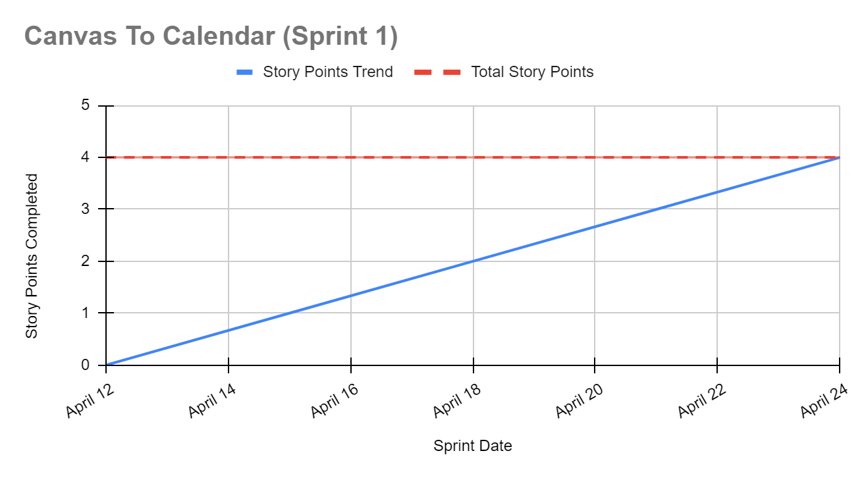

* **Scrum Board**

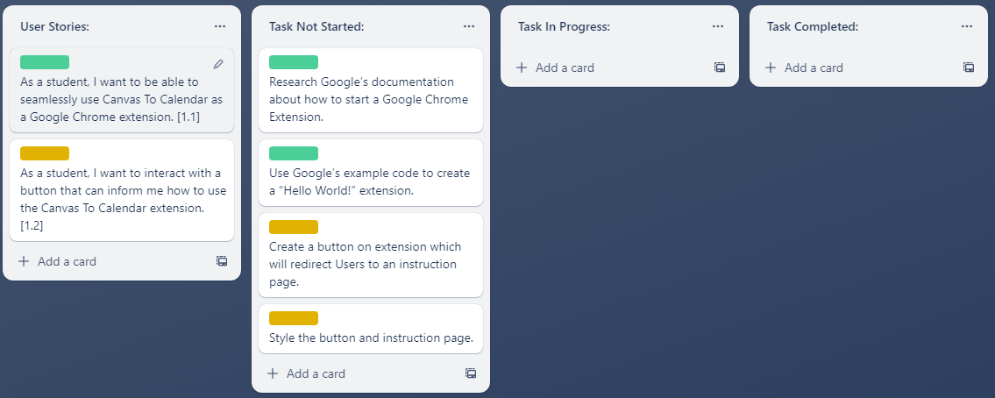

**Scrum Meeting Times**

**Monday:** In the Engineering 1, (9:15 am - 10:15 am)

**Wednesday:** After Zoom with TA, (4:50 pm - 5:20 pm)

**Friday**: Over Discord, (5:00 pm - 5:30 pm)